## Overview

It’s time to finish the main page for your imaginary furniture store that you began in the previous activity.

In this activity, you will add a second grid, both HTML and CSS, to your webpage to showcase the different product types of your online furniture store.

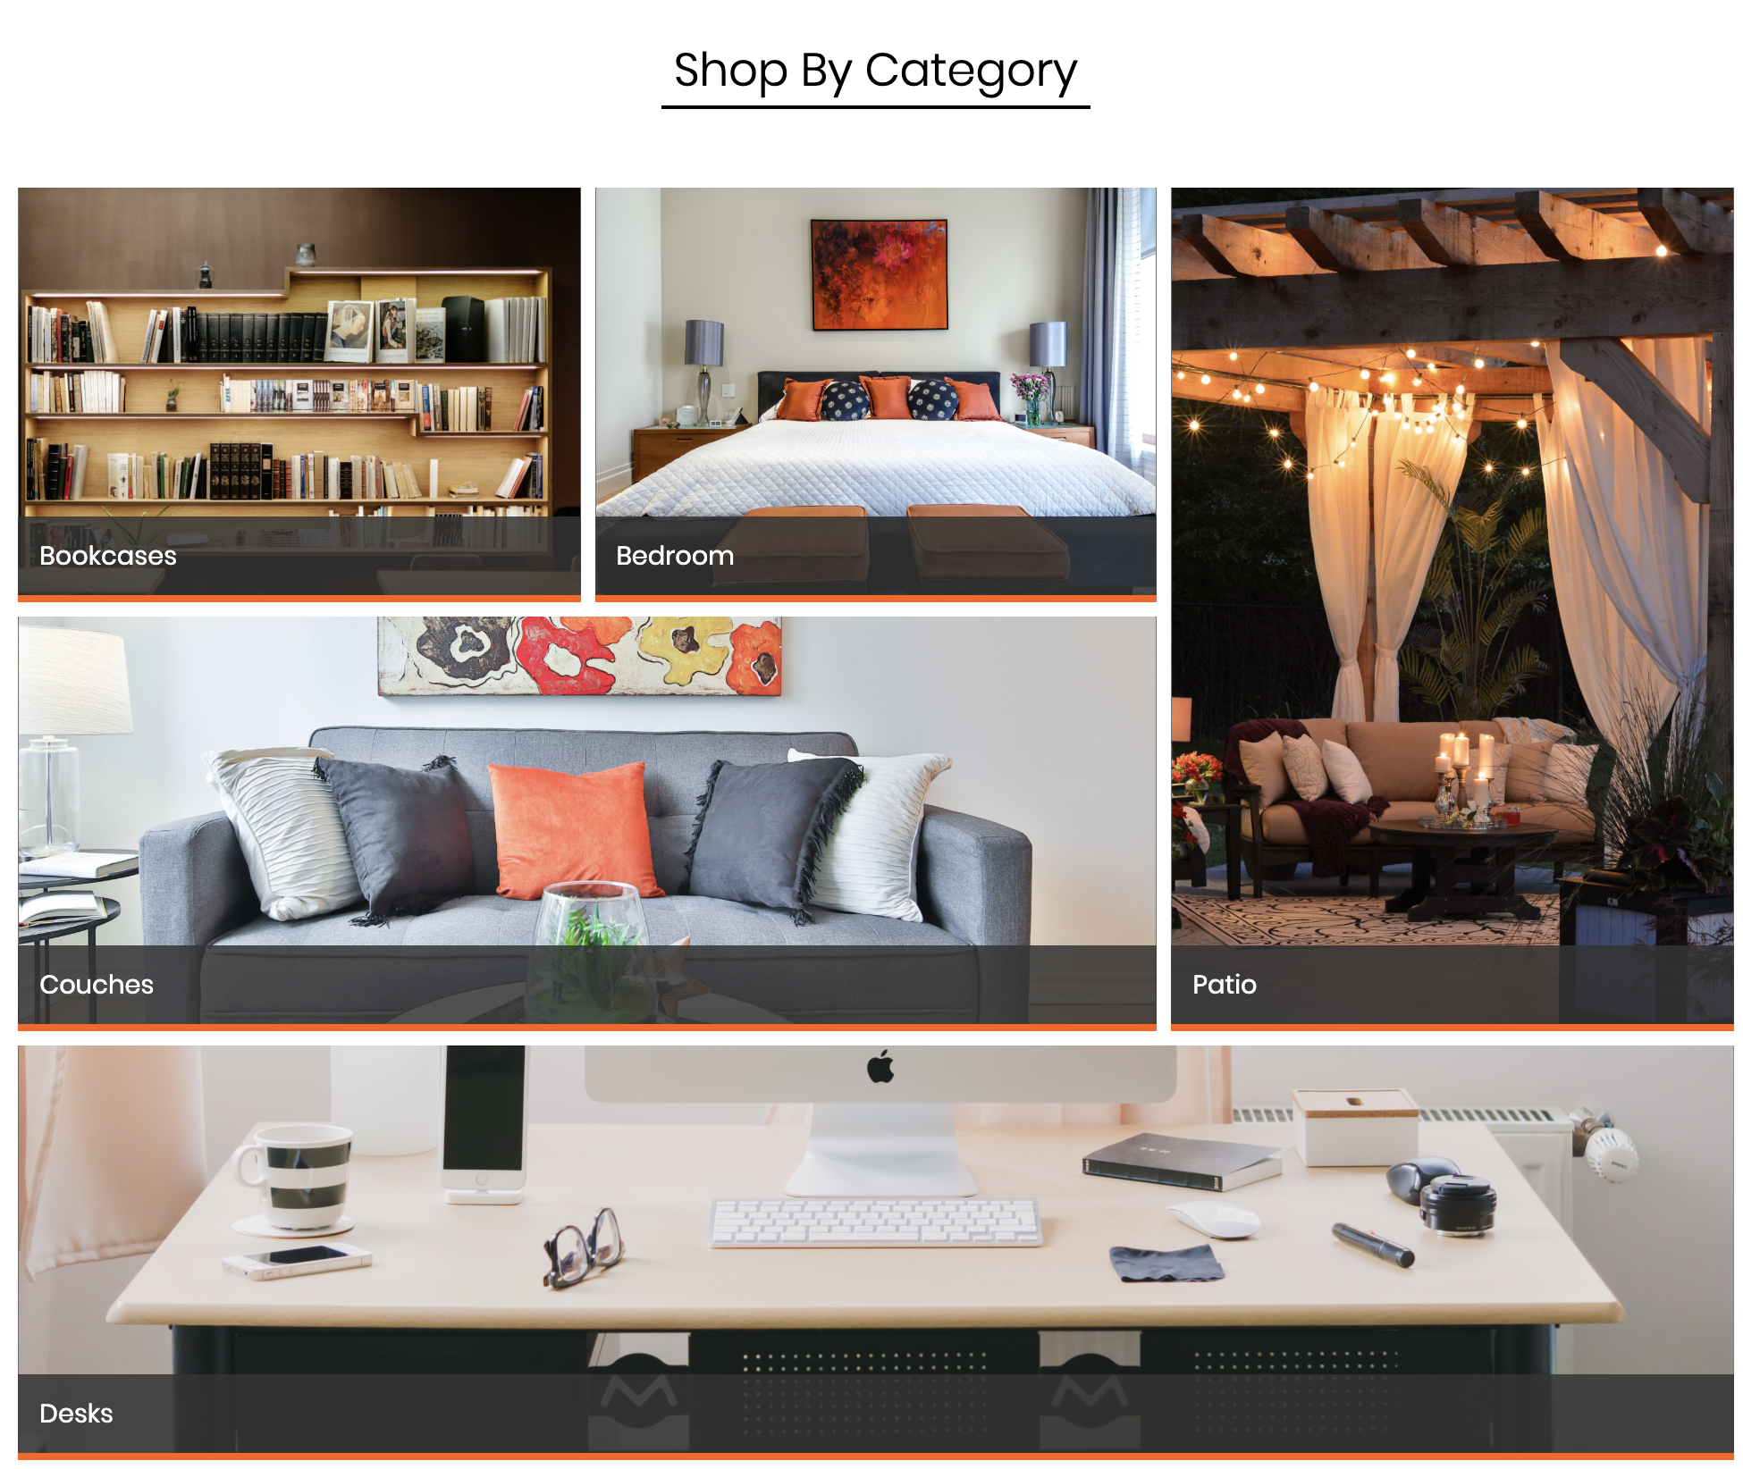

## Instructions

1. Open the index.html file.
   * *Note:* This is the same index.html file you used in the earlier activity.
2. Before creating our second grid, add a <div> with the class subHeading.
   * Create a <h3> tag and add the text “Shop By Category” within this <div>.

**Step 1: Create the Grid and Its Content**

1. Next, create the HTML tags that will be our second grid under our first. Give the second grid the ID categoryGrid.
   * *Hint: Use a <section> tag for your grid.*
2. Create the following HTML structure inside your newly created <section> tag:  
   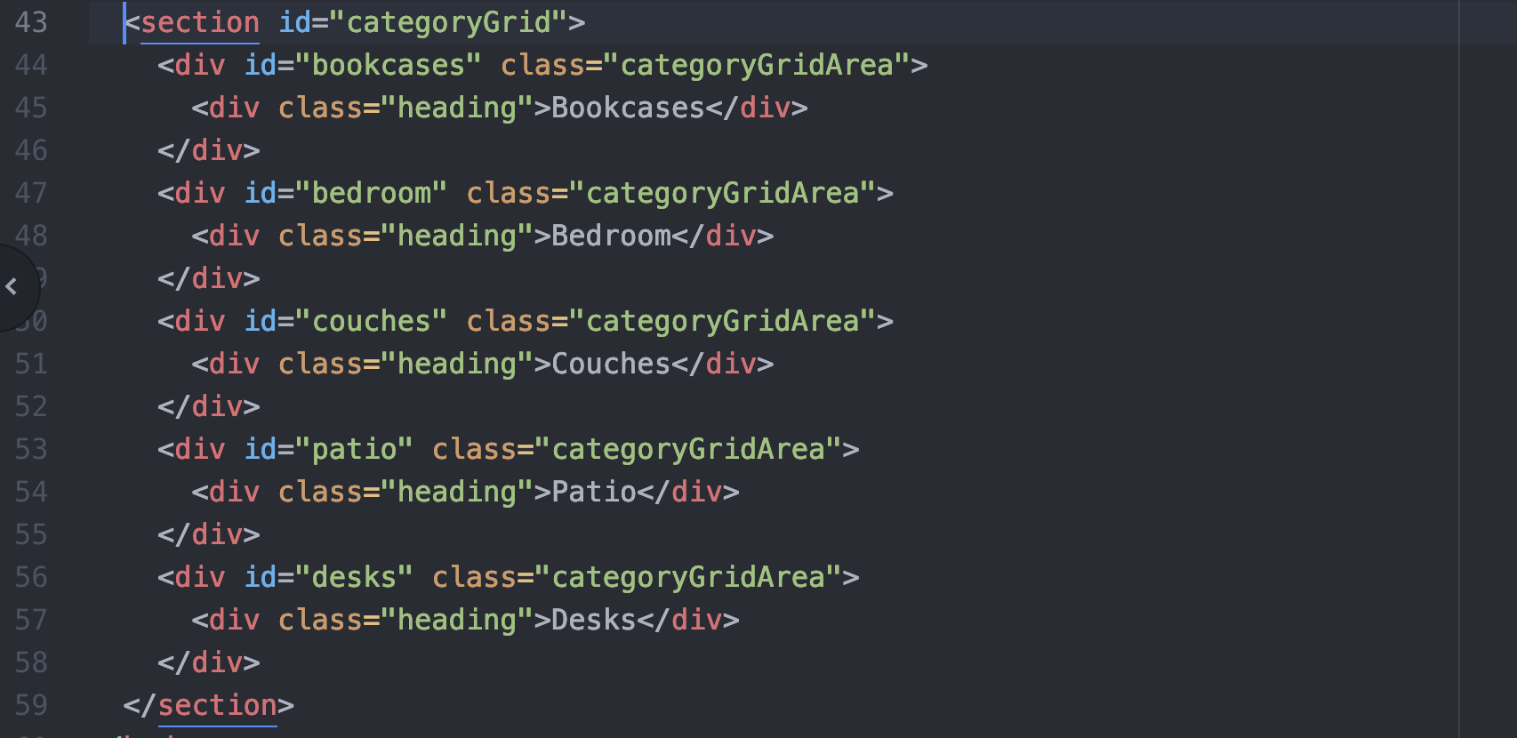
3. That’s all the HTML structure you will need for your second grid.

**Step 2: Format and Style the Grid**

1. Next, open style.css.
   * Again, you’ll also find this file in the .zip file within the Activities folder.
2. Create a selector that targets the subHeading class. Add the following:

|  |  |
| --- | --- |
| **Property** | **Value** |
| text-align | center |
| border-bottom | 2px solid black |
| width | 300px |
| margin | 50px auto |

1. Create a selector that targets your second grid using its ID.
   * Add margin: 0px 5%; and display: grid; to create your grid.
2. Use the grid-template-rows, grid-template-columns, and grid-template-areas properties to create the structure of the grid.
   * You will have three columns and three rows in this layout (note the illustration below).
   * Make your row 300px tall.
   * Each column should occupy one-third of the area (use fractional units).
   * The area should look like the diagram below:

|  |  |  |
| --- | --- | --- |
| **1** | **2** | **3** |
| **4** | |
| **5** | | |

1. Next, create **five** selectors that target each grid area you created in index.html.
   * *Hint: Remember to target the* ***ID*** *for each area.*
2. Add a background-image to each grid area selector using the images provided in the images folder.
3. Create a selector for the common grid area class categoryGridArea.
   * Add the following properties and values to this selector: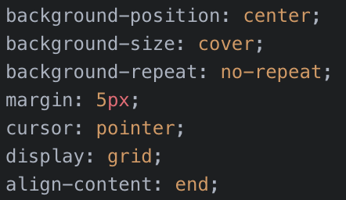
4. Lastly, create a selector to target the heading class with the following:

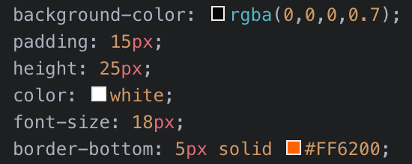

1. Now, open index.html in your browser and take a look at both grids.
2. You should notice that you’ve created a great-looking layout using nested grids!

**Resources**

* grid-template-rows documentation: <https://www.w3schools.com/cssref/pr_grid-template-rows.asp>
* grid-template-columns documentation:<https://www.w3schools.com/cssref/pr_grid-template-columns.asp>